Assignment 1:
Course Code: CSE-4251
Course Title: Data Ware-housing and Data Mining
General Instructions:
- Students are requested to submit their assignment in timely manner.
- They are also requested not to be so descriptive rather encouraged to use keyword.
- Offset A4/ Bosundhara or Normal paper will go but it is highly recommended to write only one side (only top side ) of each page but not on the both page.
- Use a cover page like the sample provided hereby with the assignment (Custom the sample accordingly)
- Please don’t copy from your friends because that may expelled you from the course and that will cause you to retake the course in the next semester.

Answer all the Questions
- What is data mining? Why do we need data mining?

- How is a data warehouse different from a database? How are they similar?

- Define each of the following data mining functionalities: characterization, discrimination, association and correlation analysis, classification, regression, clustering, and outlier analysis.

- Explain the difference and similarity between discrimination and classification, between characterization and clustering, and between classification and regression.

- Describe the steps involved in data mining (with appropriate figure) when viewed as a process of knowledge discovery.
[[
- Outliers are often discarded as noise. However, one person’s garbage could be another’s treasure. For example, exceptions in credit card transactions can help us detect the fraudulent use of credit cards. Using fraudulence detection as an example, propose two methods that can be used to detect outliers and discuss which one is more reliable.

- Briefly discuss different type of attributes used in data mining and knowledge discovery with suitable example.

- Write short notes on similarity, dissimilarity, data matrix and dissimilar matrix with appropriate example.

- Suppose that the data for analysis includes the attribute age. The age values for the data tuples are (in increasing order) 13, 15, 16, 16, 19, 20, 20, 21, 22, 22, 25, 25, 25, 25, 30, 33, 33, 35, 35, 35, 35, 36, 40, 45, 46, 52, 70.

(a) What is the mean of the data? What is the median?
(b) What is the mode of the data? Comment on the data’s modality (i.e., bimodal, trimodal, etc.).
(c) What is the midrange of the data?
(d) Can you find (roughly) the first quartile (Q1) and the third quartile (Q3) of the data?
(e) Give the five-number summary of the data.
(f) Show a boxplot of the data.
(g) How is a quantile-quantile plot different from a quantile plot?

- Suppose a hospital tested the age and body fat data for 18 randomly selected adults with the following result age

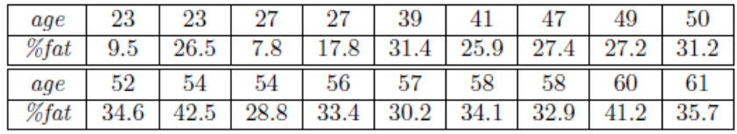

(a) Calculate the mean, median and standard deviation of age and %fat.
(b) Draw the boxplots for age and %fat.
(c) Draw a scatter plot and a q-q plot based on these two variables.

11. Briefly outline how to compute the dissimilarity between objects described by the following:
(a) Nominal attributes
(b) Symmetric and asymmetric binary attributes
(c) Ordinal attributes
(d) Numeric attributes
(e) Term-frequency vectors

- Given two objects represented by the tuples (22, 1, 42, 10) and (20, 0, 36, 8):

(a) Compute the Euclidean distance between the two objects.
(b) Compute the Manhattan distance between the two objects.
(c) Compute the Minkowski distance between the two objects, using h = 3.
(d) Compute the supremum distance between the two objects.

- Compute a dissimilarity matrix for the objects in Table bellow containing attributes of mixed type.
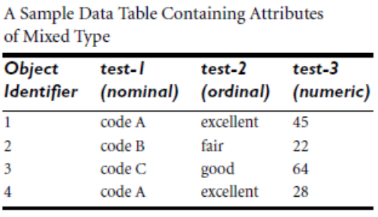
- Compute the dissimilarity of asymmetric binary attributes for the objects in the Table below.

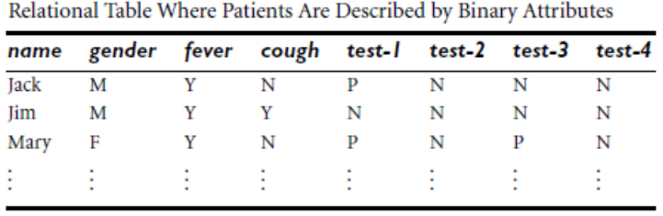

- Define Cosine similarity between two term-frequency vectors with suitable example.
Suppose that x and y are the first two term-frequency vectors such that x = (5, 0, 3, 0, 2, 0, 0, 2, 0, 0) and y=(3, 0, 2, 0, 1, 1, 0, 1, 0,1). How similar are x and y?

